
Green Society Public School
D-
Ratnanagar-7, Sauraha, Chitwan
Annual Examination-2082
Class: Four Time: 2 hrs. F.M.:50
Sub: Maths
Attempt all the questions.
1. The population of Ratnanagar Municipality is 5252410. Answer the following questions. [2+2+1]
a. Write the number of population in expanded form.
b. Round off the population to the nearest hundred.
c. What is place of 4 in the population 5252410?
2. Write the answers of the following questions. [2+2+1]
a. Convert 5 meters into centimeter.
b. If the cost of a pen is Rs. 25 then what is the cost of 4 pens?
c. How many months are there in a year?
3. Dripti cut a cake into 10 equals pieces. She ate 1 piece herself, gave 2 pieces to her mother, 3 pieces to her father and remaining pieces to her friends. [2+2+1]
a. What fraction of cake did she give to her father and mother?
b. What fraction of cake did she give to her friends?
c. What fraction of cake did she eat?
4. A rectangle white board having length 2m and its breadth is 1m. Answer the following questions. [2+2+1]
a. What is the area of wall covered by the board?
b. Find the perimeter of the board.
c. How many centimeters make 1 meter?
5. Draw a sample of a bill. [5]
6. Answer the following. [2+2+1]
a. Subtract: $3\frac{5}{2}-2\frac{1}{2}$
b. Convert the given fraction into percentage $\frac{4}{25}$
c. Compare <, > or =
4.2186 4.2225
7. Write the answers to the following. [2+2+1]
a. Construct an angle 90⁰ by using protractor.
b. Simplify: 53–231+175
c. How many sides are there in a Pentagon?
8. Write the following answers. [2+2+1]
a. Tabulate the following data
20, 22, 22, 21, 23, 24, 20, 21, 24, 23
b. Complete the number pattern.
1, 3, 5, 7, , 12.
c. Fill the number in the box.
5+ = 15
9. Answer the following. [2+2+1]
a. Find the value, when x= 5, y= 4 and z= 2.
x+y-z
b. Express algebraically.
(x+y) is divided by m.
c. Which instrument is used to measure an angle?
10. Answer the following by looking bar graph. [2+3]
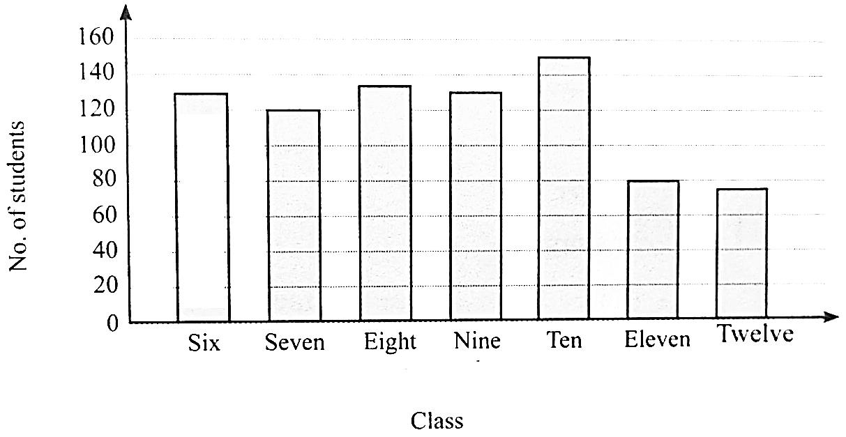

a.Which classes have the least and the most number of students?
b.What is the total number of students in the school?
***Best of Luck***

